contact: tim@noisypeople.com +1 510 717 3450

About the Filmmaker

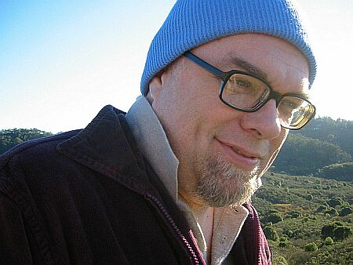
TIM PERKIS has been working in the medium of live electronic and computer sound for many years, performing, exhibiting installation works and recording in North America, Europe and Japan. His work has largely been concerned with exploring the emergence of life-like properties in complex systems of interaction. In addition, he is a well known performer in the world of improvised music; his list of collaborators reads like an international “who’s who” of innovators in free jazz and sound art, including Chris Brown, John Butcher, Eugene Chadbourne, Fred Frith, Gianni Gebbia, Frank Gratkowski, Luc Houtkamp, Yoshi Ichiraku, Joelle Leandre, Roscoe Mitchell, Gino Robair, ROVA saxophone quartet, Elliott Sharp, Leo Wadada Smith and John Zorn. Ongoing groups he has founded or played in include the League of Automatic Music Composers and the Hub -- pioneering live computer network bands -- and Rotodoti, the Natto Quartet, Fuzzybunny, All Tomorrow's Zombies and Wobbly/Perkis/Antimatter.
Born 7/19/1951, Cincinnati, Ohio, USA. Undergraduate (BA) Video and Computer Arts, University of Michigan; Graduate study Film and Video Studies California College of Arts and Crafts 1975.
Noisy People (2007) is his first feature film. Short Films include:
A Space For Possibilities: the Sound Art of Laetitia Sonami. Documentary, 11 minutes, 2006. In English.
Beauty On My Watch: Kenneth Atchley. Documentary, 12minutes, 2005. In English.

