On NOISY PEOPLE: improvising a musical life
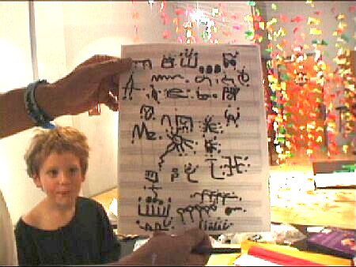
In 21st century America, the very notion of culture itself -- culture as something that arises from a community, in which all participate -- is endangered. In culture's place there is a pseudo-culture marketplace in which communities are replaced by isolated consumers who purchase entertainment products and services, and cultural professionals -- 'content providers' -- who sell to them.

In this system musical artists are professionals or amateurs, serious or not, making a living at it or not. But these categories don’t capture the realities of artists’ lives. Not all lives are built around economic striving. The artists in my film remind us that there is another way to live: pursuing a passion directly, independent of its economic value. They exemplify an alternative political and social reality, a way of life largely outside of the dominant consumer culture of the USA.

None of the people I chose to study in the films on this disc are making a living with their music, and all of them are utterly committed to their work -- and have in fact built their lives around it. Rather than waiting for commercial or critical recognition, they have found and created opportunities to perform in their own neighborhoods and in the network of venues run by like-minded people around the world.

When asked what keeps him composing and performing in the face of little recognition, K. Atchley replies: "Passion . . . or pathology”, as well as the hope that “beauty will happen on my watch. " And while none of the featured musicians, as far as I know, are overtly religious, Plonsey calls being a musician "a high calling", Greenlief calls it "a sacred thing" and for Gino Robair it is "a spiritual matter that informs your whole life. "

This film is something of a love-letter to the Bay Area music community these people have helped to build, and in which I also have participated for over 25 years. This community exemplifies many of the best attributes of democratic culture: people are prized here for their uniqueness and individuality, but there is also an understanding that all meaningful creation arises from engagement, generosity and cooperation.
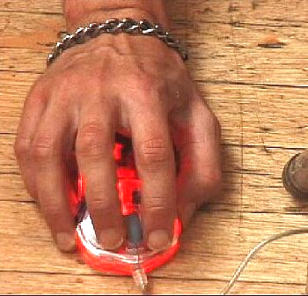
And what of the music itself? While its practitioners form a strong creative community, there is plenty of disagreement among them about what it is they are actually creating. The music seems to exist in the cracks between different established genres or communities or practices. By turns it appears on the margins of jazz, or rock, or electronic dance music, as a form of contemporary Western (classical) art music, or as sound art -- a variant of the plastic arts and not properly music at all.

There is something mysterious and wonderful about the absolute refusal of this music to be pinned down. Perhaps this is the secret of its essential aloofness from the marketplace. If, as Debussy said, music is not in the notes but between the notes, then music is at its heart ephemeral, a light and infinitely protean thing. What then could be more musical than music that doesn't even have a name?

Tim Perkis, Berkeley, Feb 14 2007

